What to Wear Guide
Nostalgic Portraits

Coordinating colors not matching.
Long gone are the days of everyone wearing a white shirt and matching. Instead, pick a couple of colors and choose clothes that will fit in this color scheme.

Look at your home decor.
Do you like bright colors? Neutrals? Since you will be hanging these photos in your house you want to make sure the colors of your clothes go with the color scheme of your home.

Don't forget accessories.
Accessories not only add to your outfit but they can be fun to use in photos. Have the man wear a tie for the woman to hold. Necklaces for the kids to play with or hats to hide behind.
Limit patterns.
Personally, I enjoy having an outfit in the mix that has all the colors in it. However, not everyone in the photo should wear patterns as it may distract the final image.

Look for clothing collections.
When shopping for clothes for my kids, I head to stores that typically have color coordinating collections. I can then purchase clothes for all the children from one store. I know their clothes will coordinate.

Plan ahead.
Once you book your session, start thinking of the clothes right away. You may think certain clothes will fit your kids or that one dress is clean. If you wait until the day of or day before you may run into an issue of clothes not fitting, being dirty or need to be dry cleaned.

Say no to characters.
Yes, your little one may love their Toy Story shirt but you may want to skip it for the family photo session. Just like patterns, characters on shirts can be pretty distracting.

Avoid all white or all black clothing.
If you are wearing an all white shirt then it is very easy to blow out parts of your shirt causing it to lose its detail. Same can be said with all black, it’s easy to have clipping on black clothing and the detail is lost.

Textures are your friend.
I am a huge fan of a cotton fitted shirt. However, in photographs I like to add textures like scarves or belts to add a little more to the image. Don’t shy away from different textures.
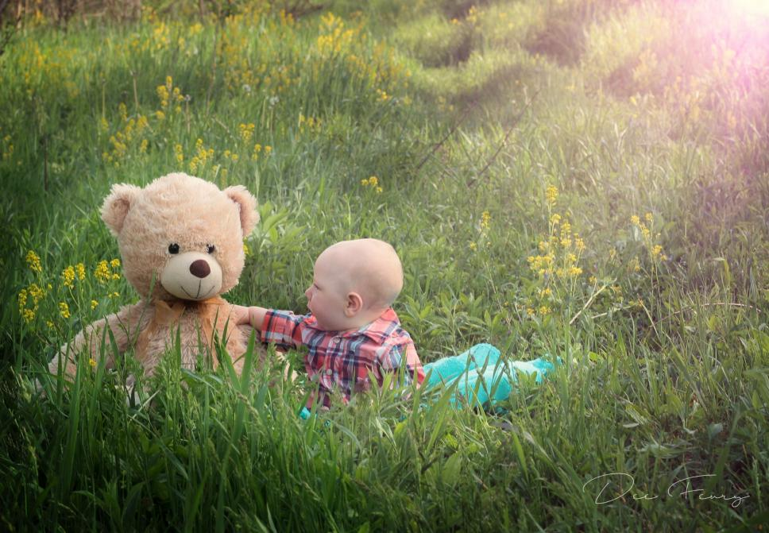
Consider your background.
If you are taking photos in front of a backdrop, consider what you are wearing. I remember and image my sister, her husband and newborn son took where they were all wearing black in front of a black backdrop. She and her husband look like floating heads holding a baby.

Think classic.
These photos will be hanging on your walls and treasured for years to come. By choosing simple, classic clothes you will help give your images a timeless feel.

